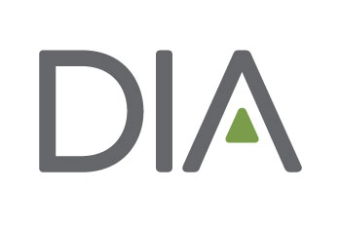
Session Abstract Form

Use this form to prepare your session abstract prior to visiting the DIA website. This will help ensure that you have all of your required information available when you submit your abstract. All abstracts must be submitted online by the designated deadline.

Should you have questions regarding the abstract submission process, please contact annualmeetingprogram@DIAglobal.org

Click here for a sample session abstract.

Abstract Title (125 character limit, including spaces): Titles should briefly describe the focus of the abstract as well as accurately reflect the content of the session.

Insert details here

Track (Select one): Choose from the list of tracks and select only one that best fits your abstract. Refer to the call for abstracts announcement for a list of tracks.

Key Words (100 character limit, including spaces): One or more key words must be provided to highlight your session. Examples of key words: Personalized Medicine, Health Technology Assessment, Clinical Trial Agreements.

Insert details here

Level of Difficulty (Select one):
O Basic: Appropriate for individuals new to the topic/subject area.
O Intermediate: Appropriate for individuals who already have a basic understanding of the topic/subject area.
O Advanced: Appropriate for individuals with an in-depth knowledge of the topic/subject area.

Learning Objectives (400 character limit, including spaces): Please provide 2-3 learning objectives that clearly explain what participants should be able to do after attending this event. Click here for a list of suggested verbs to create these objectives.

Insert details here

Overview (250 character limit, including spaces): Please provide 2-3 sentences summarizing your abstract. This summary will be used as the overview description in the DIA program for marketing purposes.

Insert details here

Abstract Details (2,000 character limit, including spaces):
Please provide complete details about your abstract. Information such as scientific, technical, process issues, design/methods, results/outcomes, case studies, statistics, key findings, etc., that would support your abstract should be included here. This information will be used by the Program Committee to learn more about the purpose of your abstract. Include proposed speaker information (not including the author) to round out the details supporting your abstract. Please do not invite speaker(s) until receiving a response from DIA regarding the status of your submission.
If the abstract is being submitted on behalf of a specific DIA Community, please note that in the abstract text portion of the submission.

Speaker Details
Please indicate at least two individual, along with contact information, who will be invited to participate in the offering. Note: please do not extend an invitation until receiving final status of your abstract. If you have not identified any specific speakers, you may include information regarding possible speakers in the ABSTRACT DETAILS section above.

The following information will need to be completed. Fields followed by an * are required.
Prefix:
First Name:*
Middle Name:
Last Name:*
Name Suffix:
Degrees:*
Job Title:*
Company:*
Address Line:*
City:*
State/Province:*
Zip/Postal Code:*
Country:*
Phone:*
email:*

