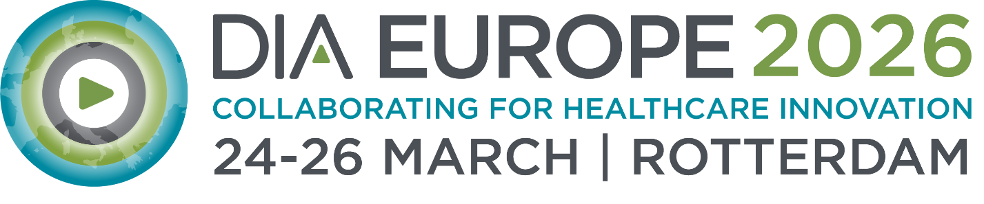
Justification Letter, In-Person Participation
Below, you'll find a "justification letter" template — a letter to your supervisor explaining all the benefits you'll get from attending the DIA Europe 2026 in-person, how the insights from the conference enhance your day-to-day work and help advancing your organization.
This general template will get you started while allowing you to customize it to you and your organization's particular needs.
---------------
<Date>
Dear <Supervisor’s name>,
I am seeking your support to attend DIA Europe Conference, 24-26 March 2026 in Rotterdam, the Netherlands.
This meeting brings together a unique community of life sciences professionals at all levels and across all disciplines, all with the common goal of fostering “Collaboration for Healthcare Innovation” that will lead to the development of safe and effective medical products and therapies to improve patient outcomes. Exclusive insights and discussions on neutral grounds make this conference special. The DIA Europe 2026 provides the greatest opportunity to meet with senior experts in drug development and especially regulators from around the world to expand networks for our organization. Attending the conference in person allows networking also in informal rounds and occasions.
An anticipated 1,500+ attendees, including industry professionals (from 200+ pharma companies), clinicians, 20+ patient organizations, 40+ regulatory agencies and 12+ payers and HTA bodies from more than 50 countries, will attend and present at this event. In addition, I will have access to the industry exhibition and networking activities and the on-demand content for 2 month after the event.
While attending this meeting, I will be able to participate in a number of interdisciplinary, cross-functional educational offerings with real world applications.

The conference programme was prepared by the distinguished programme committee in collaboration with DIA.
80+ sessions planned across 10 tracks featured ranging from:

<select interest areas applicable to you>

- Clinical Trials Innovation
- CMC & Quality
- Artificial Intelligence & RWE
- Global Insights
- Innovative Therapies, Precision Medicine & Diagnostics
- Medical Devices & Combination Products
- Pharmacovigilance & Safety
- Regulatory Operations
- Regulatory Strategy & EU Pharmaceutical Policy
- Value & Access

NEW in 2026 – the below priority areas were defined will be covered from different tracks:
- A Competitive EU Regulatory & Lifesciences Ecosystem
- The Role of Innovation in the Future of Healthcare
- Data, Digitalisation & AI
- Collaboration
- Capacity Building, New Skill sets and Sustainability of the System
I am seeking your support in attending this meeting.
Registration Fee: Insert your registration fee from here
Estimated - Travel Expenses:
Estimated - Accommodation Expenses:
Other Expenses:
Thank you for taking the time to review this proposal. By attending DIA Europe 2026 having the opportunity to develop my skills, gain knowledge, and establish key contacts which will be a valuable investment for my profession, colleagues, and <insert name of your organization here>.
Sincerely,

